NAME - SHRESTHA DEY
SupersetID - 7719638
DN-5.0 JavaFSE Solutions

WEEK-1 : PL/SQL

Exercise 1: Control Structures

Scenario 1: The bank wants to apply a discount to loan interest rates for customers above 60 years old.
  - Question: Write a PL/SQL block that loops through all customers, checks their age, and if they are above 60, apply a 1% discount to their current loan interest rates.
Scenario 2: A customer can be promoted to VIP status based on their balance.
  - Question: Write a PL/SQL block that iterates through all customers and sets a flag IsVIP to TRUE for those with a balance over $10,000.
Scenario 3: The bank wants to send reminders to customers whose loans are due within the next 30 days.
  - Question: Write a PL/SQL block that fetches all loans due in the next 30 days and prints a reminder message for each customer.

Step 1: Create table and insert values

CREATE TABLE Customers (
CustomerID INT PRIMARY KEY,
Name VARCHAR2(100),
DOB DATE,
Balance NUMBER(15,2),
IsVIP VARCHAR2(5)
);
CREATE TABLE Loans (
LoanID INT PRIMARY KEY,
CustomerID INT,
InterestRate NUMBER(5,2),
DueDate DATE
);
-- Step 2: Insert Sample Data
INSERT INTO Customers VALUES (1, 'John Smith', DATE '1950-05-10', 15000, 'FALSE');
INSERT INTO Customers VALUES (2, 'Alice Brown', DATE '1985-03-22', 8000, 'FALSE');
INSERT INTO Customers VALUES (3, 'Bob Wilson', DATE '1955-11-01', 12000, 'FALSE');
INSERT INTO Loans VALUES (101, 1, 8.5, SYSDATE + 10);
INSERT INTO Loans VALUES (102, 2, 7.0, SYSDATE + 45);
INSERT INTO Loans VALUES (103, 3, 9.0, SYSDATE + 20);
COMMIT;

Scenario 1:
DECLARE
CURSOR cur_senior_loans IS
SELECT l.LoanID,
l.InterestRate,
c.CustomerID,
TRUNC(MONTHS_BETWEEN(SYSDATE, c.DOB) / 12) AS Age
FROM Customers c
JOIN Loans l ON l.CustomerID = c.CustomerID;
v_age NUMBER;
v_new_rate NUMBER;
BEGIN
FOR rec IN cur_senior_loans LOOP
v_age := rec.Age;
IF v_age > 60 THEN
v_new_rate := rec.InterestRate - 1;
IF v_new_rate < 0 THEN
v_new_rate := 0;
END IF;
UPDATE Loans
SET InterestRate = v_new_rate
WHERE LoanID = rec.LoanID;
DBMS_OUTPUT.PUT_LINE(
'CustomerID ' || rec.CustomerID ||
' (Age ' || v_age || '): LoanID ' || rec.LoanID ||
' rate updated to ' || v_new_rate || '%'
);
END IF;
END LOOP;
COMMIT;
DBMS_OUTPUT.PUT_LINE('Scenario 1 complete - senior loan discounts applied.');
EXCEPTION
WHEN OTHERS THEN
ROLLBACK;
DBMS_OUTPUT.PUT_LINE('Error: ' || SQLERRM);
END;
/
OUTPUT:
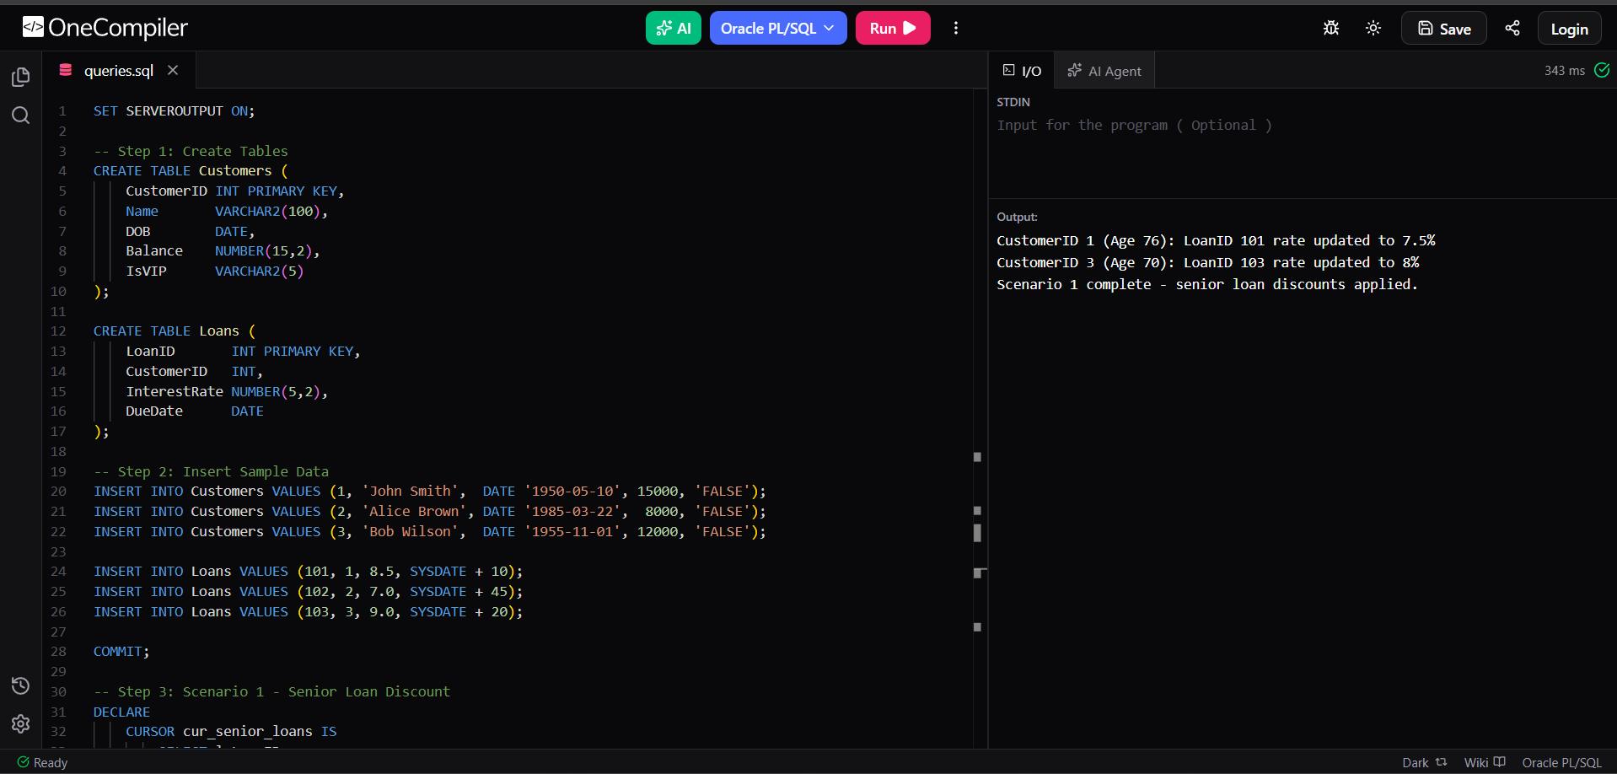

Scenario 2:
DECLARE
CURSOR cur_customers IS
SELECT CustomerID, Balance
FROM Customers;
v_customerID INT;
v_balance NUMBER(15,2);
BEGIN
FOR rec IN cur_customers LOOP
IF rec.Balance > 10000 THEN
UPDATE Customers
SET IsVIP = 'TRUE'
WHERE CustomerID = rec.CustomerID;
DBMS_OUTPUT.PUT_LINE(
'CustomerID ' || rec.CustomerID ||
' promoted to VIP (Balance: $' || rec.Balance || ')'
);
ELSE
UPDATE Customers
SET IsVIP = 'FALSE'
WHERE CustomerID = rec.CustomerID;
DBMS_OUTPUT.PUT_LINE(
'CustomerID ' || rec.CustomerID ||
' is Standard (Balance: $' || rec.Balance || ')'
);
END IF;
END LOOP;
COMMIT;
DBMS_OUTPUT.PUT_LINE('Scenario 2 complete - VIP flags updated.');
EXCEPTION
WHEN OTHERS THEN
ROLLBACK;
DBMS_OUTPUT.PUT_LINE('Error: ' || SQLERRM);
END;
/
OUTPUT:
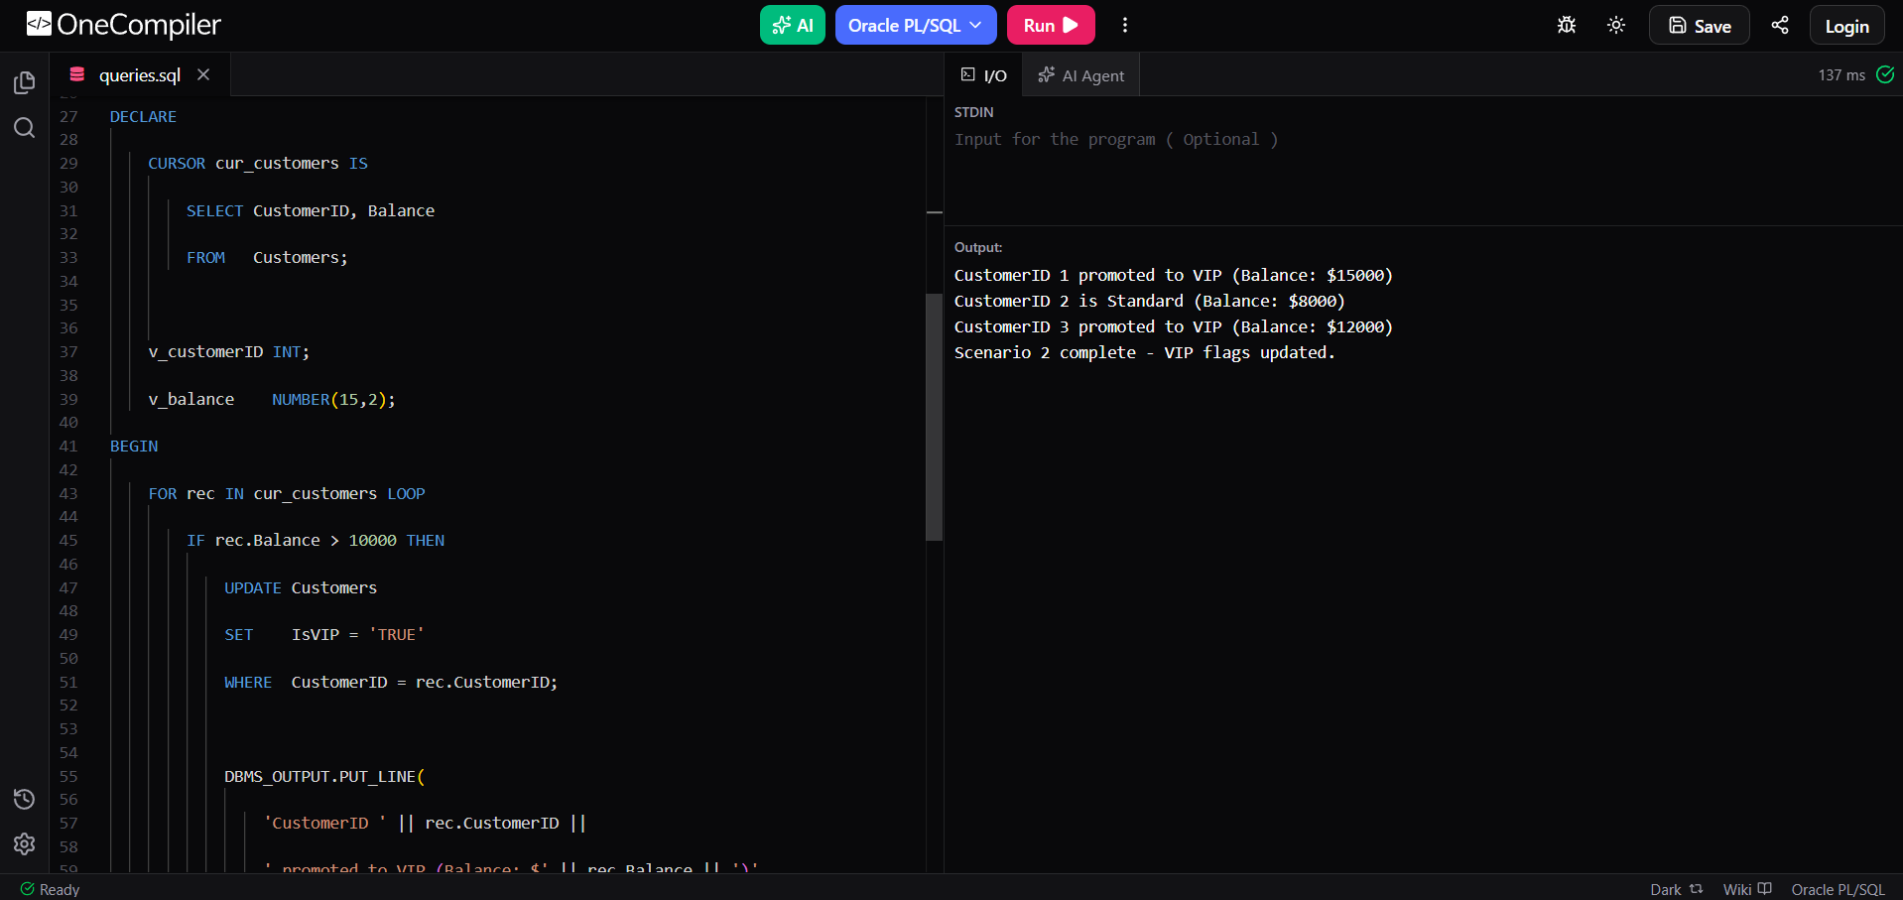

Scenario 3:

DECLARE
CURSOR cur_due_loans IS
SELECT l.LoanID,
l.DueDate,
c.CustomerID,
c.Name
FROM Loans l
JOIN Customers c ON c.CustomerID = l.CustomerID
WHERE l.DueDate BETWEEN SYSDATE AND SYSDATE + 30
ORDER BY l.DueDate;
v_days_left NUMBER;
BEGIN
DBMS_OUTPUT.PUT_LINE('=== Loan Due-Date Reminders (next 30 days) ===');
FOR rec IN cur_due_loans LOOP
v_days_left := TRUNC(rec.DueDate - SYSDATE);
DBMS_OUTPUT.PUT_LINE(
'REMINDER – Dear ' || rec.Name ||
' (CustomerID: ' || rec.CustomerID || '),' ||
' your LoanID ' || rec.LoanID ||
' is due on ' || TO_CHAR(rec.DueDate, 'DD-MON-YYYY') ||
' (' || v_days_left || ' day(s) remaining). Please ensure timely payment.'
);
END LOOP;
IF cur_due_loans%ROWCOUNT = 0 THEN
DBMS_OUTPUT.PUT_LINE('No loans are due in the next 30 days.');
END IF;
DBMS_OUTPUT.PUT_LINE('Scenario 3 complete – reminders printed.');
EXCEPTION
WHEN OTHERS THEN
DBMS_OUTPUT.PUT_LINE('Error in Scenario 3: ' || SQLERRM);
END;
/
OUTPUT:

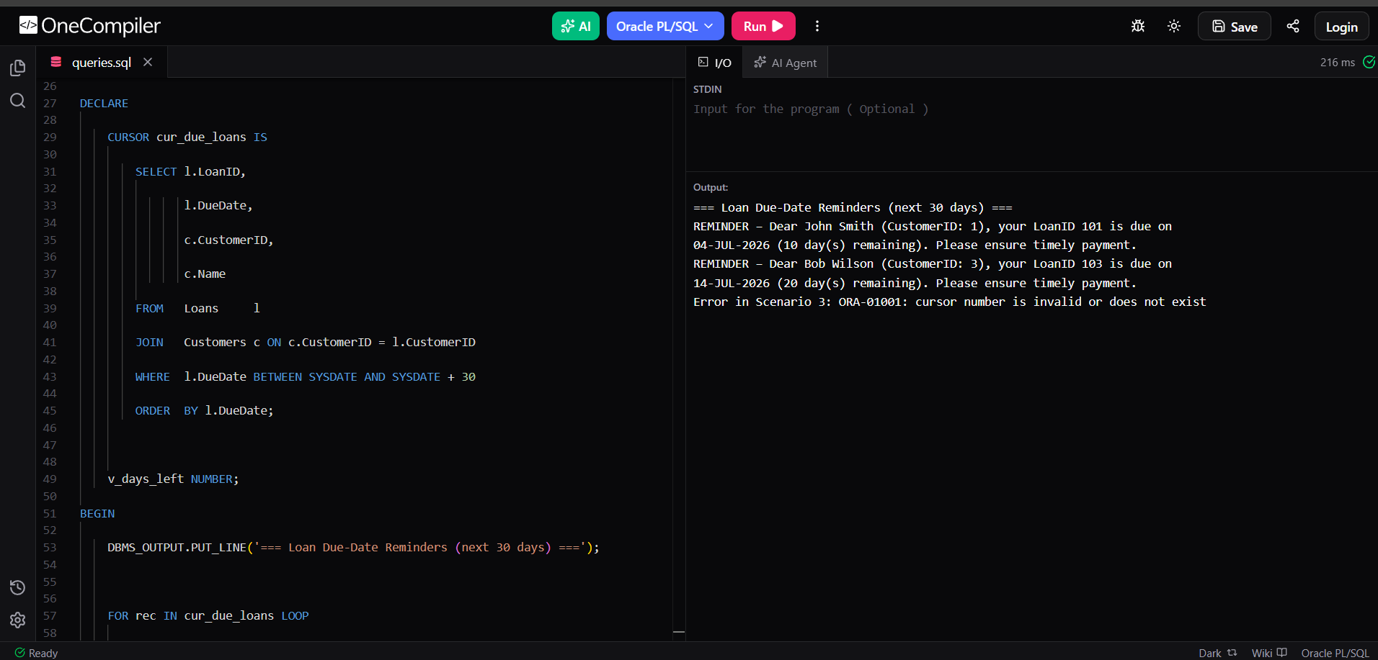

Exercise 3: Stored Procedures

Scenario 1: The bank needs to process monthly interest for all savings accounts.
  - Question: Write a stored procedure ProcessMonthlyInterest that calculates and updates the balance of all savings accounts by applying an interest rate of 1% to the current balance.

Scenario 2: The bank wants to implement a bonus scheme for employees based on their performance.
  - Question: Write a stored procedure UpdateEmployeeBonus that updates the salary of employees in a given department by adding a bonus percentage passed as a parameter.

Scenario 3: Customers should be able to transfer funds between their accounts.
  - Question: Write a stored procedure TransferFunds that transfers a specified amount from one account to another, checking that the source account has sufficient balance before making the transfer.

Step 1 : Create Table and Insert values

-- Create Table
CREATE TABLE Accounts (
AccountID INT PRIMARY KEY,
CustomerID INT,
AccountType VARCHAR2(20),
Balance NUMBER(15,2)
);
-- Insert Data
INSERT INTO Accounts VALUES (201, 1, 'Savings', 15000);
INSERT INTO Accounts VALUES (202, 2, 'Savings', 8000);
INSERT INTO Accounts VALUES (203, 3, 'Current', 12000);
INSERT INTO Accounts VALUES (204, 4, 'Savings', 5000);
COMMIT;
Scenario 1:

CREATE OR REPLACE PROCEDURE ProcessMonthlyInterest AS
CURSOR cur_savings IS
SELECT AccountID, Balance
FROM Accounts
WHERE AccountType = 'Savings';
v_interest NUMBER;
v_new_bal NUMBER;
v_count NUMBER := 0;
BEGIN
FOR rec IN cur_savings LOOP
v_interest := rec.Balance * 0.01;
v_new_bal := rec.Balance + v_interest;
UPDATE Accounts
SET Balance = v_new_bal
WHERE AccountID = rec.AccountID;
v_count := v_count + 1;
DBMS_OUTPUT.PUT_LINE(
'AccountID ' || rec.AccountID ||
': Old Balance $' || rec.Balance ||
' | Interest $' || v_interest ||
' | New Balance $' || v_new_bal
);
END LOOP;
COMMIT;
DBMS_OUTPUT.PUT_LINE(
'ProcessMonthlyInterest complete - ' || v_count || ' account(s) updated.'
);
OUTPUT:

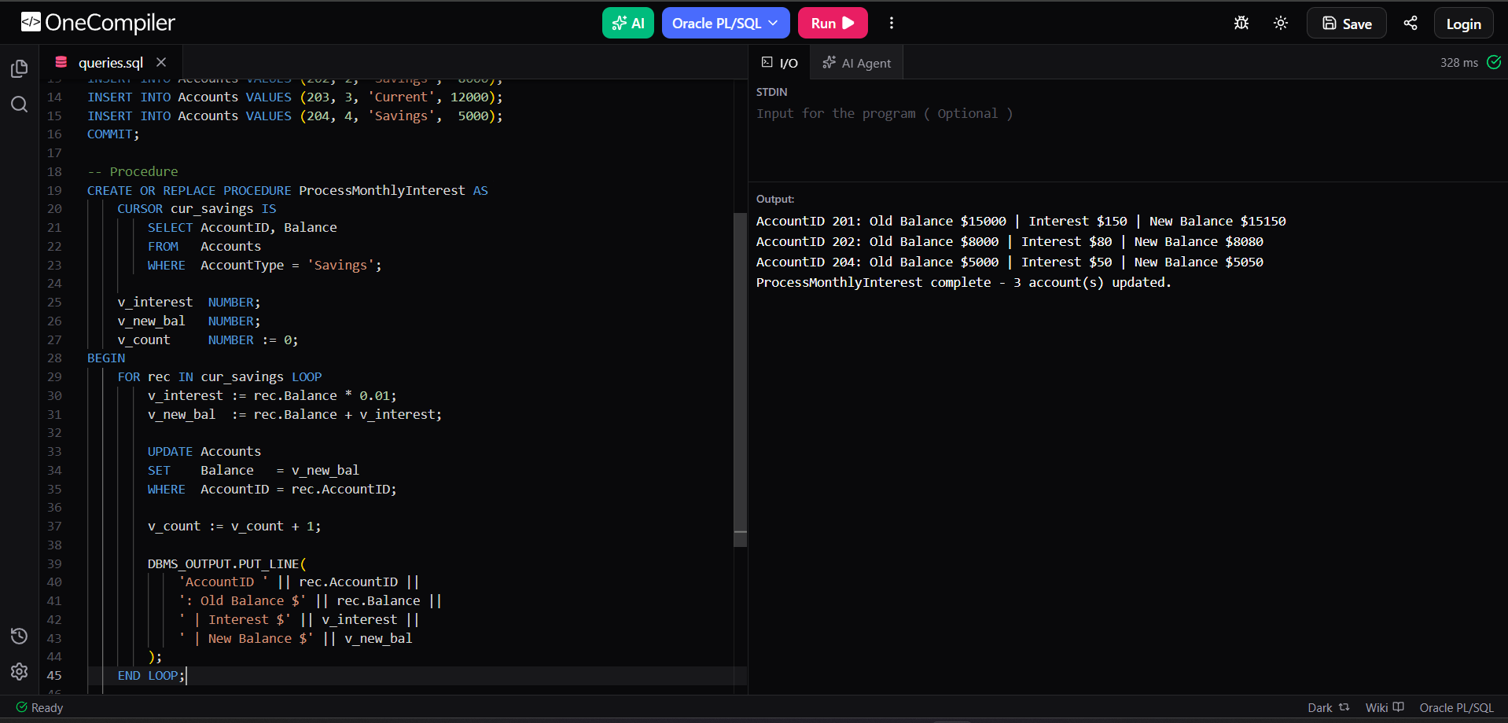

Scenario 2 :

(After creating the table and inserting the values, the procedure is written.)

SET SERVEROUTPUT ON;

-- Create Table
CREATE TABLE Employees (
EmployeeID INT PRIMARY KEY,
DepartmentID INT,
Name VARCHAR2(100),
Salary NUMBER(15,2)
);

-- Insert Data
INSERT INTO Employees VALUES (1, 10, 'Alice', 50000);
INSERT INTO Employees VALUES (2, 10, 'Bob', 60000);
INSERT INTO Employees VALUES (3, 20, 'Charlie', 45000);
INSERT INTO Employees VALUES (4, 20, 'Diana', 55000);
INSERT INTO Employees VALUES (5, 30, 'Eve', 70000);
COMMIT;

-- Procedure
CREATE OR REPLACE PROCEDURE UpdateEmployeeBonus (
p_department_id IN NUMBER,
p_bonus_pct IN NUMBER
) AS
v_count NUMBER := 0;
BEGIN
IF p_bonus_pct <= 0 THEN
RAISE_APPLICATION_ERROR(-20001, 'Bonus percentage must be greater than zero.');
END IF;

FOR rec IN (
SELECT EmployeeID, Name, Salary
FROM Employees
WHERE DepartmentID = p_department_id
) LOOP
UPDATE Employees
SET Salary = Salary + (Salary * p_bonus_pct / 100)
WHERE EmployeeID = rec.EmployeeID;

v_count := v_count + 1;

DBMS_OUTPUT.PUT_LINE(
'EmployeeID ' || rec.EmployeeID ||
' (' || rec.Name || ')' ||
': Old Salary $' || rec.Salary ||
' | Bonus ' || p_bonus_pct || '%' ||
' | New Salary $' || ROUND(rec.Salary + (rec.Salary * p_bonus_pct / 100), 2)
);
END LOOP;

IF v_count = 0 THEN
DBMS_OUTPUT.PUT_LINE('No employees found in DepartmentID ' || p_department_id);
ELSE
COMMIT;
DBMS_OUTPUT.PUT_LINE(
'UpdateEmployeeBonus complete - ' || v_count ||
' employee(s) in Dept ' || p_department_id ||
' received ' || p_bonus_pct || '% bonus.'
);
END IF;

EXCEPTION
WHEN OTHERS THEN
ROLLBACK;
DBMS_OUTPUT.PUT_LINE('Error: ' || SQLERRM);
END UpdateEmployeeBonus;
/

-- Run the Procedure (Department 10, 15% bonus)
EXEC UpdateEmployeeBonus(10, 15);

OUTPUT:

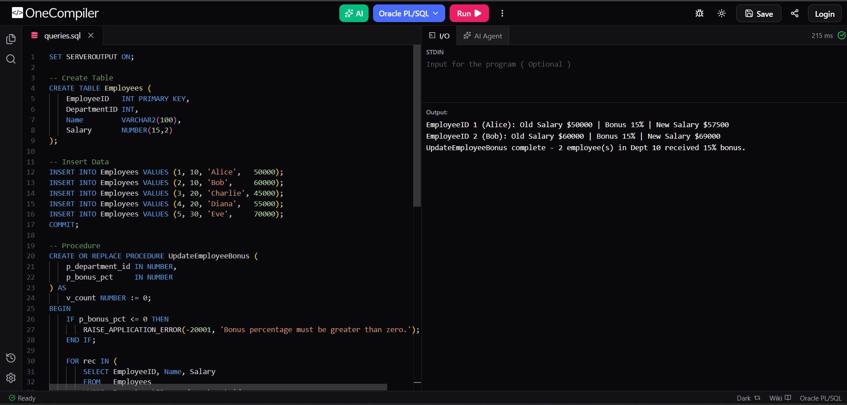

Scenario 3:

(After creating the table and inserting the values, the procedure is written.)

SET SERVEROUTPUT ON;
-- Create Table
CREATE TABLE Accounts (
AccountID INT PRIMARY KEY,
CustomerID INT,
AccountType VARCHAR2(20),
Balance NUMBER(15,2)
);
-- Insert Data
INSERT INTO Accounts VALUES (101, 1, 'Savings', 10000);
INSERT INTO Accounts VALUES (202, 2, 'Savings', 5000);
INSERT INTO Accounts VALUES (303, 3, 'Current', 2000);
COMMIT;
-- Procedure
CREATE OR REPLACE PROCEDURE TransferFunds (
p_from_account_id IN NUMBER,
p_to_account_id IN NUMBER,
p_amount IN NUMBER
) AS
v_source_balance NUMBER;
v_source_exists NUMBER;
v_dest_exists NUMBER;
BEGIN
-- Validate amount
IF p_amount <= 0 THEN
RAISE_APPLICATION_ERROR(-20010, 'Transfer amount must be greater than zero.');
END IF;
-- Check source exists
SELECT COUNT(*) INTO v_source_exists
FROM Accounts
WHERE AccountID = p_from_account_id;
IF v_source_exists = 0 THEN
RAISE_APPLICATION_ERROR(-20011, 'Source account does not exist.');
END IF;
-- Check destination exists
SELECT COUNT(*) INTO v_dest_exists
FROM Accounts
WHERE AccountID = p_to_account_id;
IF v_dest_exists = 0 THEN
RAISE_APPLICATION_ERROR(-20012, 'Destination account does not exist.');
END IF;
-- Get source balance
SELECT Balance INTO v_source_balance
FROM Accounts
WHERE AccountID = p_from_account_id
FOR UPDATE;
-- Check sufficient funds
IF v_source_balance < p_amount THEN
RAISE_APPLICATION_ERROR(
-20013,
'Insufficient funds! Available: $' || v_source_balance ||
' | Requested: $' || p_amount
);
END IF;
-- Debit source
UPDATE Accounts
SET Balance = Balance - p_amount
WHERE AccountID = p_from_account_id;
-- Credit destination
UPDATE Accounts
SET Balance = Balance + p_amount
WHERE AccountID = p_to_account_id;
COMMIT;
DBMS_OUTPUT.PUT_LINE(
'Transfer Successful!' ||
' $' || p_amount ||
' transferred from AccountID ' || p_from_account_id ||
' to AccountID ' || p_to_account_id
);
-- Show updated balances
FOR rec IN (
SELECT AccountID, Balance
FROM Accounts
WHERE AccountID IN (p_from_account_id, p_to_account_id)
) LOOP
DBMS_OUTPUT.PUT_LINE(
'AccountID ' || rec.AccountID ||
' updated Balance: $' || rec.Balance
);
END LOOP;
EXCEPTION
WHEN OTHERS THEN
ROLLBACK;
DBMS_OUTPUT.PUT_LINE('Error: ' || SQLERRM);
END TransferFunds;
/
-- Run the Procedure (Transfer $500 from Account 101 to Account 202)
EXEC TransferFunds(101, 202, 500);

OUTPUT:

